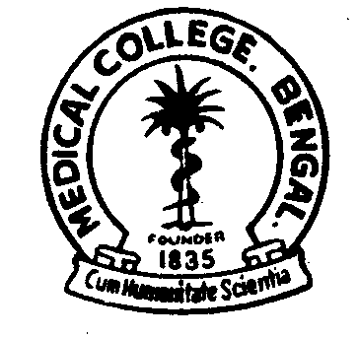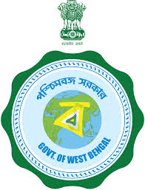
GOVERNMENT OF WEST BENGAL
OFFICE OF THE PRINCIPAL
MEDICAL COLLEGE, KOLKATA
88, COLLEGE STREET, KOLKATA – 700073

Memo No. MC/ /2022 Dated: 25.03.2022

N O T I C E
Institutional Ethics Committee, Medical College, Kolkata is reconstituted comprising of the following members as below with immediate effect until further Order:
    - Prof. Nandita basu, Ex-Director, School of Tropical Medicine &, M.C., Kol. - Chairperson
    - Prof. Debasis Das, HOD, Community Medicine, Medical College, Kolkata. - Member Secretary
    - Prof. Dipak Kumar Sarkar, Head, Dept Of Pharmacology, M.C.,Kol. - Basic Scientist
    - Prof. Aniruddha Sengupta, Dept. Of Orthopaedics, M.C.,Kol. - Clinician
    - Prof. Bibhuti Saha, Head, , School Of Tropical Medicine, Kolkata., M.C.,Kol. - Clinician
    - Dr. Bhawna Bhutoria Jain, Associate Prof., Dept. Of Pathology, M.C.K. - Basic Scientist
    - Dr. Sebanti Bhattacharyya, Associate Prof. & O.C., Dr. A.P.J Abdul Kalam Govt., M.C.,K. - Philosopher
    - Dr. Raja Bhattacharyya, Assistant Prof., Dept of Medicine, Medical College, Kolkata. - Clinician
    - Dr. Avishek Bhadra, Asstt Prof., Dept of G & O, Medical College, Kolkata - Clinician
    - Sri Hironlal Majumder, Advocate, Hon’ble High Court, Medical College, Kolkata. - Legal Expert
    - Sri Asok Kar, Teacher, Medical College, Kolkata. - Lay Person

Principal
Medical College, Kolkata

No. MC/ /1(11)/2022 Dated: 25.03.2022
Copy forwarded for information & necessary action to:
- Prof. Nandita basu, Ex-Director, School of Tropical Medicine, Medical College, Kolkata.
- Prof. Debasis Das, HOD, Community Medicine, Medical College, Kolkata.
- Prof. Dipak Kumar Sarkar, Head, Dept Of Pharmacology, Medical College, Kolkata.
- Prof. Aniruddha Sengupta, Dept. Of Orthopaedics, Medical College, Kolkata.
- Prof. Bibhuti Saha, Head, , School Of Tropical Medicine, Kolkata, Medical College, Kolkata.
- Dr. Bhawna Bhutoria Jain, Associate Prof., Dept. Of Pathology, Medical College, Kolkata.
- Dr. Sebanti Bhattacharyya, Associate Prof. & O.C., Dr. A.P.J Abdul Kalam Govt., Medical College, Kolkata.
- Dr. Raja Bhattacharyya, Assistant Prof., Dept of Medicine, Medical College, Kolkata.
- Dr. Avishek Bhadra, Asstt Prof., Dept of G & O, Medical College, Kolkata
- Sri Hironlal Majumder, Advocate, Hon’ble High Court, Medical College, Kolkata.
- Sri Asok Kar, Teacher, Medical College, Kolkata.

Principal
Medical College, Kolkata

